Worksheet - 3

- Aim(A): To implement classification algorithms—Logistic Regression, Decision Tree, and k-Nearest Neighbour’s (k-NN)—on a suitable dataset and evaluate their performance using confusion matrix, precision, recall, and F1-score.

- Objective(A): To implement Logistic Regression and Polynomial Regression algorithms on a suitable dataset and evaluate their performance using confusion matrix, precision, recall, and F1-score, in order to understand and compare the effectiveness of regression-based machine learning techniques for prediction and classification tasks.

- Code(A):
LOGISTIC REGRESSION
print("=" * 65)
print("PART 1: LOGISTIC REGRESSION CLASSIFICATION")
print("=" * 65)
target_col = 'evidence level - score. 0 = no evidence, 1,2 = slight, 3 = conflicting , 4 = promising, 5 = good, 6 = strong '
df['Target'] = (df[target_col] >= 4).astype(int)
features_lr = [
'popularity',
'number of studies examined',
'number of citations',
'Cochrane systematic review',
'Other International review board or metastudy',
'No. of individual studies / reviews'
]
X_lr = df[features_lr]
y_lr = df['Target']
X_train_lr, X_test_lr, y_train_lr, y_test_lr = train_test_split(
X_lr, y_lr, test_size=0.2, random_state=42, stratify=y_lr
)
lr_model = LogisticRegression(max_iter=1000)
lr_model.fit(X_train_lr, y_train_lr)
y_pred_lr = lr_model.predict(X_test_lr)
cm_lr = confusion_matrix(y_test_lr, y_pred_lr)
acc_lr = accuracy_score(y_test_lr, y_pred_lr)
prec_lr = precision_score(y_test_lr, y_pred_lr, zero_division=0)
rec_lr = recall_score(y_test_lr, y_pred_lr, zero_division=0)
f1_lr = f1_score(y_test_lr, y_pred_lr, zero_division=0)
print("\nLogistic Regression Results")
print("Confusion Matrix:")
print(cm_lr)
print(f"\nAccuracy : {acc_lr:.4f}")
print(f"Precision : {prec_lr:.4f}")
print("\nClassification Report:")
print(classification_report(y_test_lr, y_pred_lr, zero_division=0))
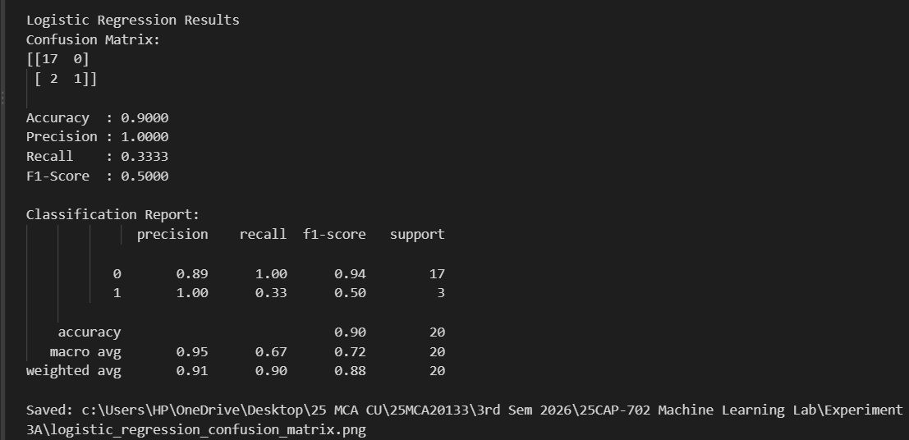

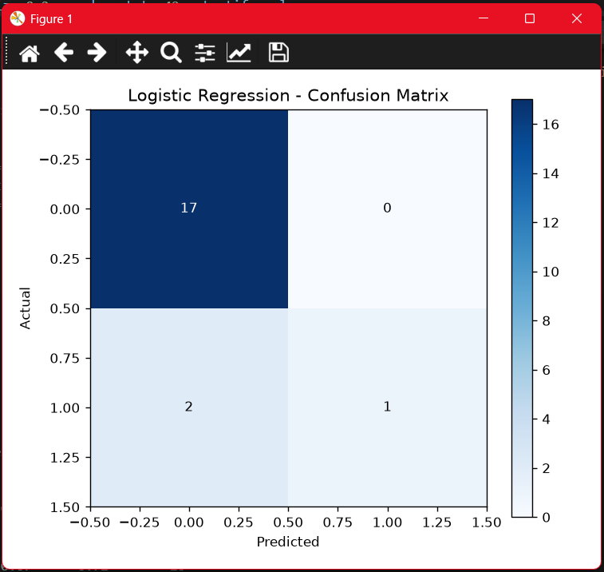

\

POLYNOMIAL REGRESSION
print("\n" + "=" * 65)
print("PART 2: POLYNOMIAL REGRESSION CLASSIFICATION")
print("=" * 65)
score_column = df.columns[2]
data_poly = df[['popularity', score_column]].copy()
data_poly.columns = ['popularity', 'evidence_score']
data_poly['popularity'] = pd.to_numeric(data_poly['popularity'], errors='coerce')
data_poly['evidence_score'] = pd.to_numeric(data_poly['evidence_score'], errors='coerce')
data_poly = data_poly.dropna()
print(f"Cleaned records for Polynomial Regression: {len(data_poly)}")
X_p = data_poly[['popularity']]
y_p = data_poly['evidence_score']
X_train_p, X_test_p, y_train_p, y_test_p = train_test_split(
X_p, y_p, test_size=0.20, random_state=42
)
print(f"Training samples: {len(X_train_p)}, Testing samples: {len(X_test_p)}")
poly_model = make_pipeline(
PolynomialFeatures(degree=2),
LinearRegression()
)
poly_model.fit(X_train_p, y_train_p)
y_pred_p = poly_model.predict(X_test_p)
mae_p = mean_absolute_error(y_test_p, y_pred_p)
mse_p = mean_squared_error(y_test_p, y_pred_p)
rmse_p = np.sqrt(mse_p)
r2_p = r2_score(y_test_p, y_pred_p)
print("\nREGRESSION PERFORMANCE")
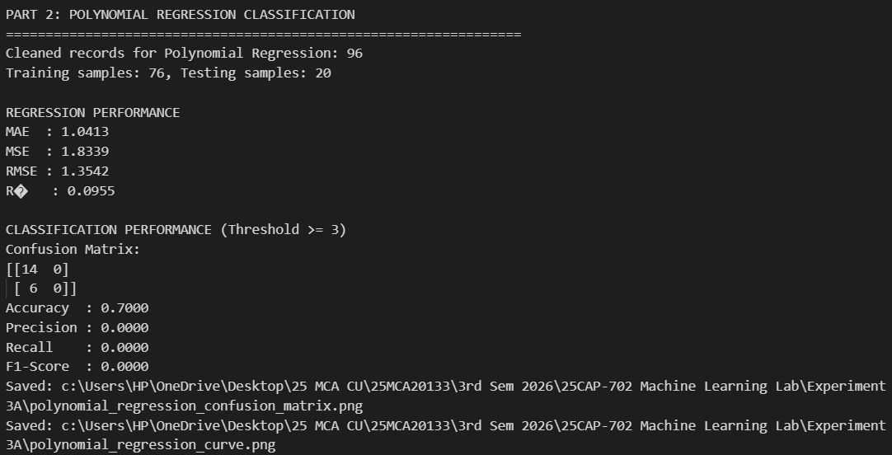
print(f"MAE : {mae_p:.4f}")

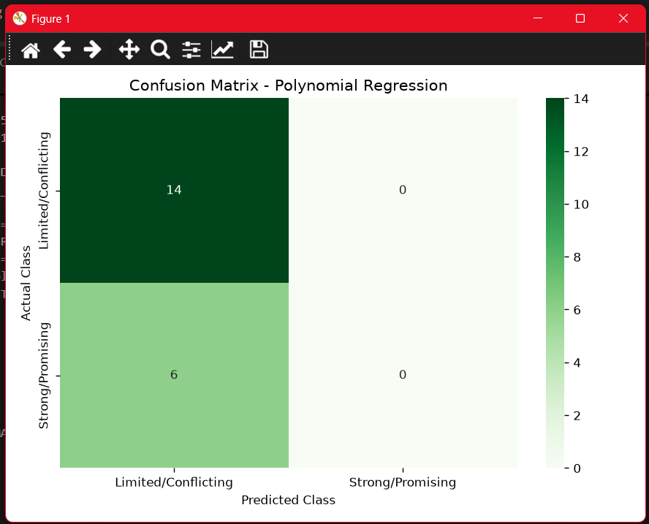

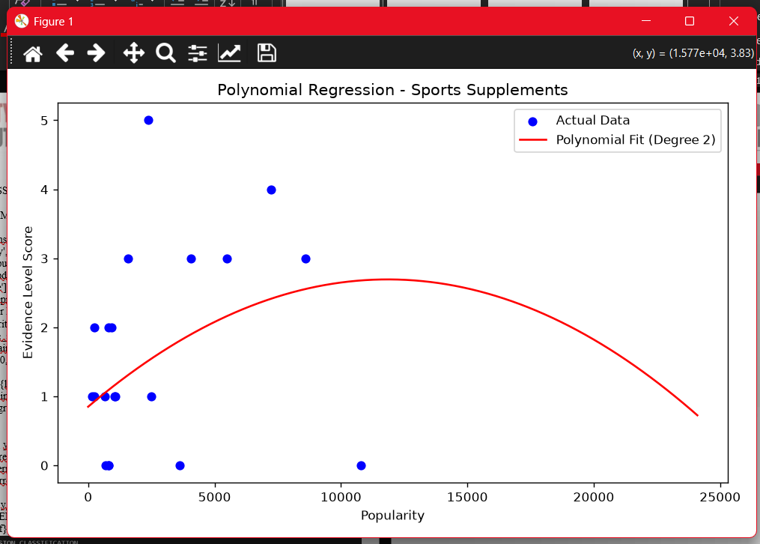

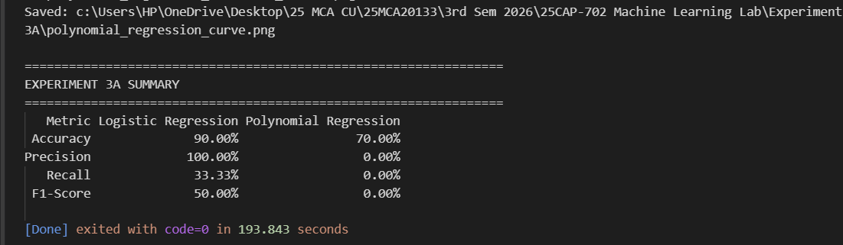

- Learning outcomes(A):
1. Understood and implement Polynomial Regression for predicting continuous values.
2. Applied data preprocessing and prepare a suitable dataset for model training.
3. Divided the dataset into training and testing sets for model evaluation.
4. Transformed input features into polynomial features and train a regression model.

- Aim(B): Implement classification algorithms— Decision Tree, and k-NN— on a suitable dataset and evaluate their performance using confusion matrix, precision, recall, and F1-score.

- Objective(B): To implement Decision Tree and k-Nearest Neighbour’s (k-NN) classification algorithms on a suitable dataset and evaluate their performance using confusion matrix, precision, recall, and F1-score to compare their effectiveness in classification tasks.

- Code(B): Decision Tree
import os
import pandas as pd
import matplotlib.pyplot as plt
from sklearn.model_selection import train_test_split
from sklearn.tree import DecisionTreeClassifier, plot_tree
from sklearn.metrics import confusion_matrix, precision_score, recall_score, f1_score, classification_report
csv_filename = "Sports Supplements.csv"
if os.path.exists(csv_filename):
csv_path = csv_filename
elif os.path.exists(os.path.join(os.path.dirname(os.path.abspath(__file__)), csv_filename)):
csv_path = os.path.join(os.path.dirname(os.path.abspath(__file__)), csv_filename)
elif os.path.exists("OneDrive/Desktop/Machine Learning/Sports Supplements.csv"):
csv_path = "OneDrive/Desktop/Machine Learning/Sports Supplements.csv"
else:
csv_path = r"C:\Users\HP\OneDrive\Desktop\Machine Learning\Sports Supplements.csv"
df = pd.read_csv(csv_path)
print(f"Dataset loaded successfully from: {csv_path}")
print(f"Dataset shape: {df.shape}")
target = 'evidence level - score. 0 = no evidence, 1,2 = slight, 3 = conflicting , 4 = promising, 5 = good, 6 = strong '
df['Target'] = (df[target] >= 4).astype(int)

features = [
'popularity',
'number of studies examined',
'number of citations',
'Cochrane systematic review',
'Other International review board or metastudy',
'No. of individual studies / reviews'
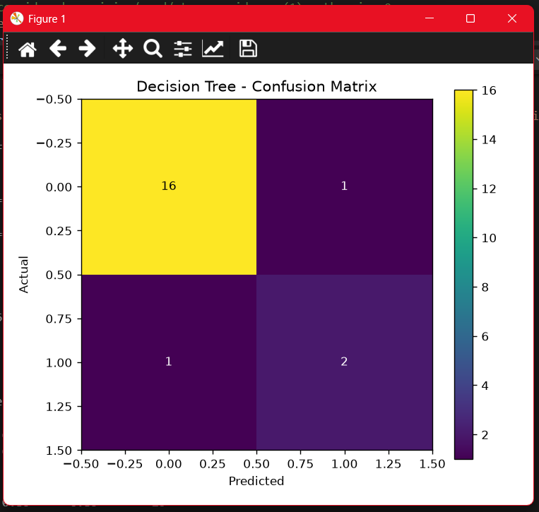

plt.tight_layout()
cm_plot_path = os.path.join(os.path.dirname(os.path.abspath(__file__)), "decision_tree_confusion_matrix.png")
plt.savefig(cm_plot_path, dpi=300)
print(f"Confusion matrix plot saved to: {cm_plot_path}")
plt.show()
plt.figure(figsize=(15, 8))
plot_tree(
model,
feature_names=features,
class_names=["Low Evidence", "Good Evidence"],
filled=True,
rounded=True,
fontsize=9
)
plt.title("Decision Tree Visualization")
tree_plot_path = os.path.join(os.path.dirname(os.path.abspath(__file__)), "decision_tree_structure.png")
plt.savefig(tree_plot_path, dpi=300, bbox_inches='tight')
print(f"Decision tree structure saved to: {tree_plot_path}")
plt.show()
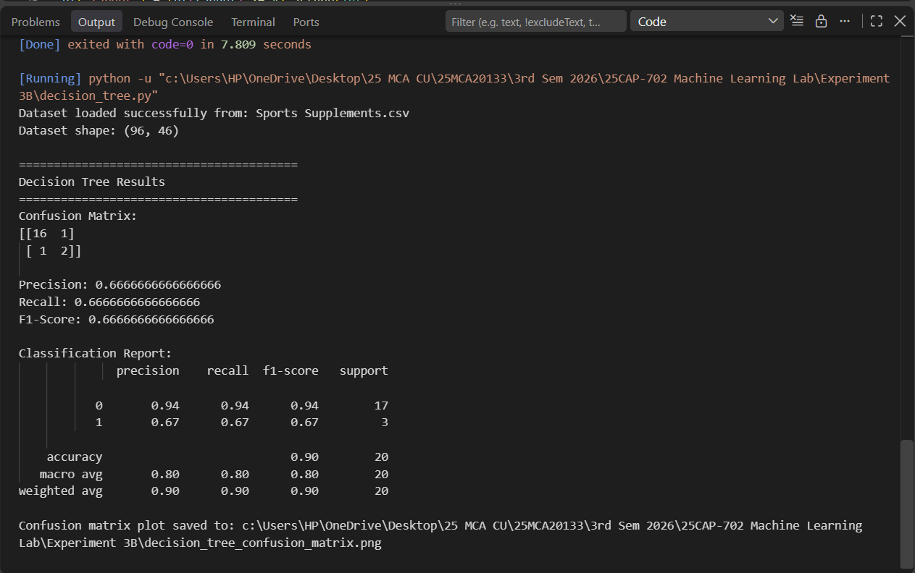

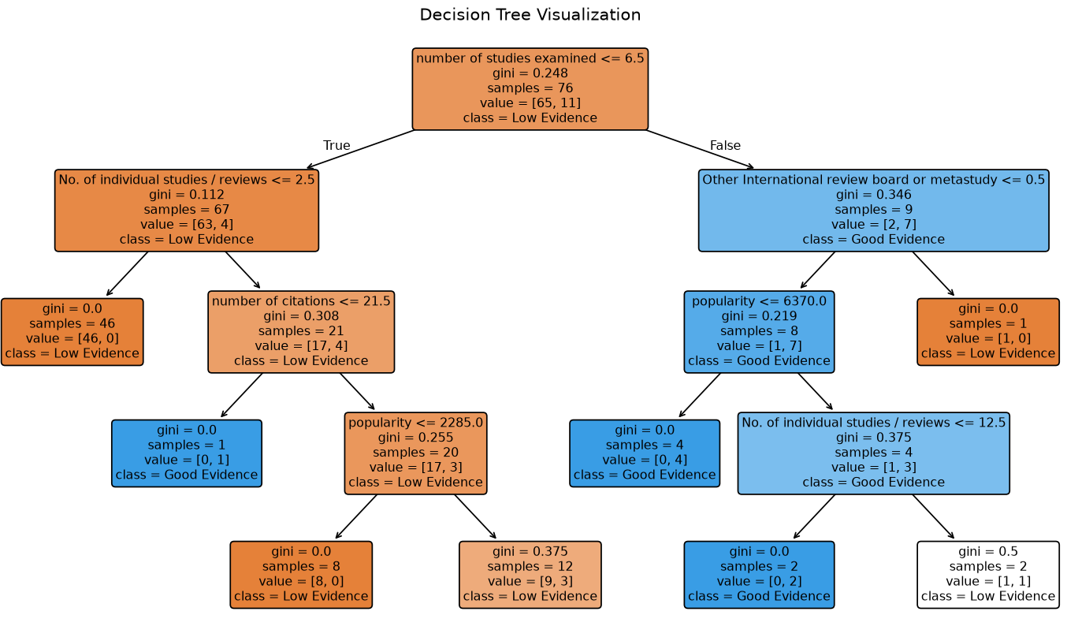

k-NN :
import os
import pandas as pd
import numpy as np
from sklearn.model_selection import train_test_split
from sklearn.preprocessing import StandardScaler
from sklearn.neighbors import KNeighborsClassifier
from sklearn.metrics import (
confusion_matrix,
precision_score,
recall_score,
f1_score,
accuracy_score,
classification_report
)
import matplotlib.pyplot as plt
import seaborn as sns
csv_filename = "Sports Supplements.csv"
if os.path.exists(csv_filename):
csv_path = csv_filename
elif os.path.exists(os.path.join(os.path.dirname(os.path.abspath(__file__)), csv_filename)):
csv_path = os.path.join(os.path.dirname(os.path.abspath(__file__)), csv_filename)
elif os.path.exists("OneDrive/Desktop/Machine Learning/Sports Supplements.csv"):
csv_path = "OneDrive/Desktop/Machine Learning/Sports Supplements.csv"
else:
csv_path = r"C:\Users\HP\OneDrive\Desktop\Machine Learning\Sports Supplements.csv"
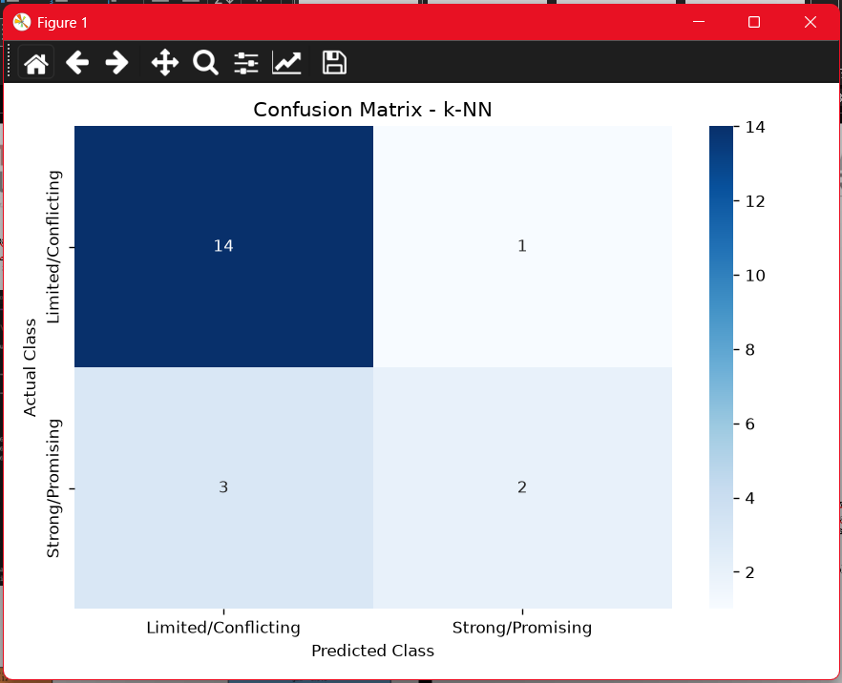

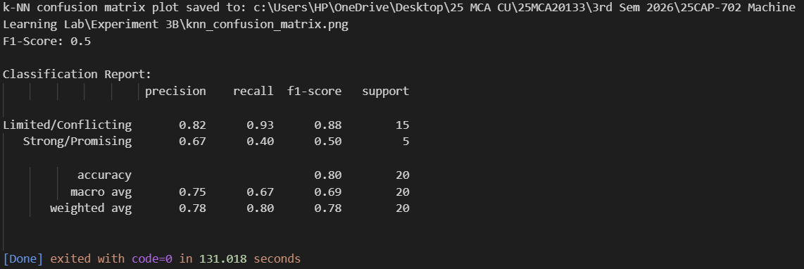

- Learning outcomes(B):
1. Implemented Decision Tree and k-NN classification algorithms on a suitable dataset.
2. Evaluated model performance using confusion matrix, precision, recall, and F1-score.
3. Compared the performance of Decision Tree and k-NN classifiers.
4. Interpreted classification results and identify the better-performing model.

